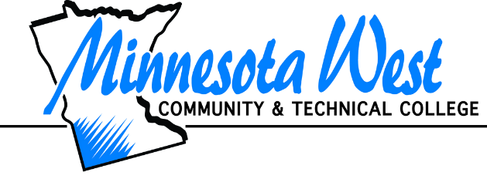

**Request for Accessibility & Disability Services**

**Minnesota West Community & Technical College**

You can either print out this form and complete by hand or fill in the blanks electronically and attach the completed document to an email addressed to: [**salome.chonko@mnwest.edu**](mailto:salome.chonko@mnwest.edu)

Name: Click or tap here to enter text.

Address: Click or tap here to enter text.

City: Click or tap here to enter text.

State: Click or tap here to enter text. Zip: Click or tap here to enter text.

Primary Phone: Click or tap here to enter text.

Student ID/StarID #: Click or tap here to enter text.

Email: Click or tap here to enter text.

Program/Major: Click or tap here to enter text.

Start Date: Click or tap here to enter text.

# Disability: Click or tap here to enter text.

**\*\*\*Appropriate documentation of your disability must be provided to qualify for services.**

Please describe how your disability impacts your learning:

Click or tap here to enter text.

Please list the desired accommodations you have used in the past and/or would like to obtain:

Click or tap here to enter text.

Do you have a counselor from Rehabilitation Services (DRS) or another agency who is assisting you with your career goals? If so, who is your counselor and their contact information?

Click or tap here to enter text.

Other things you would like to share:

Click or tap here to enter text.



I give permission for this information to be shared with my instructors, LARC and Agency staff. I understand what services are available to me through the office of Accessibility & Disability Services and my responsibilities in obtaining those services. I agree to provide any necessary documentation of my disability and to keep the office informed of any changes in my school status. Minnesota West requires notification of accommodations within a reasonable time of date required in order to make arrangements. If an interpreter is needed, we need three weeks notification in order to make arrangements.

Either print form and sign by hand or type in your StarID.

Signature Click or tap here to enter text.

Date Click or tap here to enter text.

**Complete and submit this request and ALL DOCUMENTATION of your disability either in person, by fax, or through email to the Disability Coordinator:**

**Salome Chonko**

**Minnesota West Community and Technical College**

**401 West Street, PO Box 269**

**Jackson MN 56143**

**Phone: 507-847-7970**

**Fax: 507-847-5389**

[**salome.chonko@mnwest.edu**](mailto:salome.chonko@mnwest.edu)

|  |
| --- |
| **This document is available in alternative formats to individuals with disabilities by contacting the Student Services Advisor or by calling 800-658-2330 or via your preferred Telecommunications Relay Service**.    **A Member of the Minnesota State Colleges and Universities System**  **An Affirmative Action Equal Opportunity Educator/Employer** |