Minnesota West Community & Technical College
Style Guide

Colors
The official Minnesota West colors are:
Blue - Pantone 3005
R=3, G=111, B=176
C=90%, M=57%, Y=11%, K=1%
Hex #036FB0
Royal Blue can be substituted on certain products that do not have the color flexibility.
The accent colors are white and black and gray.
Logo Usage
Minnesota West logo: These are the official logos and are currently in use. The logo may be used in solid white with black or blue background. The logo can also be solid black when printing a black & white publication. Manipulation of color, proportions, or fonts is not permissible. The official Minnesota West logo must be included on all publications:
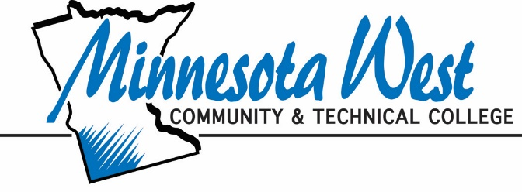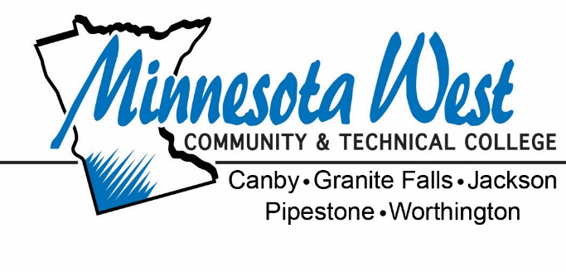

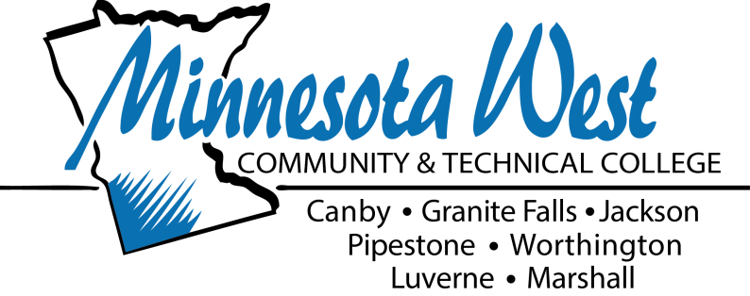

Slogan/Statement
The new/official slogan came from a graduation speech by a 2010 Surgical Tech graduate - “Learn with Purpose.”
Minnesota State statement: All publications must include the Minnesota State statement.
Minnesota West Community & Technical College is accredited by the
Higher Learning Commission North Central Association.
A member of Minnesota State colleges and universities
An Affirmative Action Equal Opportunity Educator/Employer
Deaf and Hard of Hearing Minnesota Relay Service 800-627-3529

College Name Usage
Use any of the following approved college name variations. Other formats should not be used.
Minnesota West Community & Technical College
Minnesota West Community and Technical College (acceptable, but ampersand is usually used)
Minnesota West
For second reference: MW or MWCTC is acceptable.
Note: MN West or MnWest should not be used. (These spellings are easily confused with a bank and a technology campus.)
Acceptable Wording for Minnesota State (formerly called MnSCU)
Minnesota State colleges and universities (No capital first letter on “college” and “universities”)
colleges and universities of Minnesota State (No capital first letter on “colleges” and “universities”)
Minnesota State system office (No capital first letter on “system office”)
A member of Minnesota State
Minnesota West Community & Technical College, a member of Minnesota State
A member of the Minnesota State system (No capital first letter on “system”)
MnSCU is no longer acceptable.

Updated 06/2017

