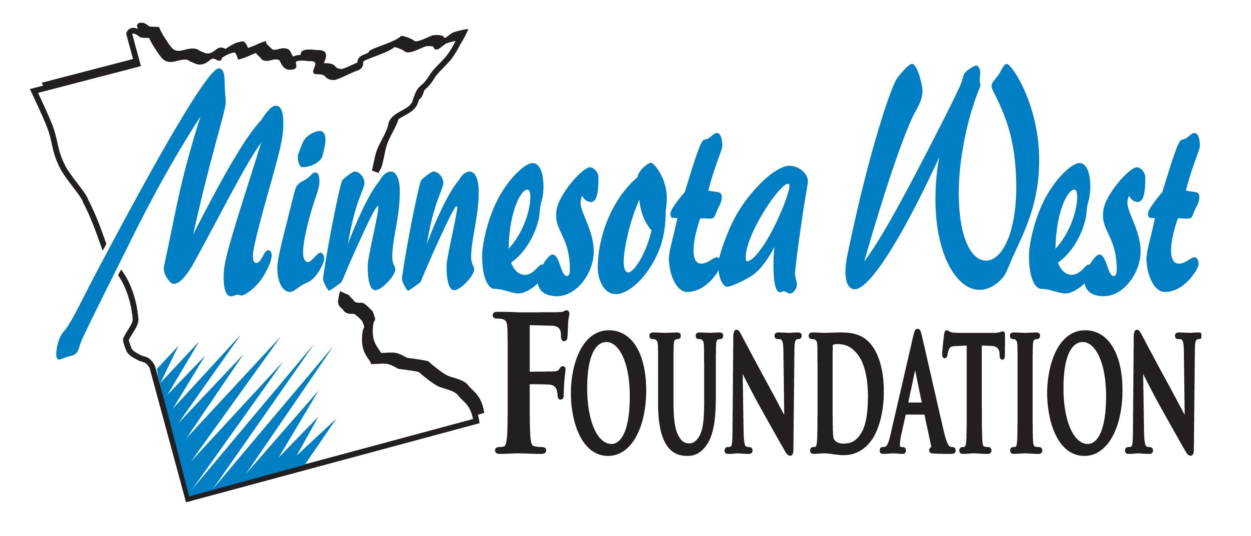

Scholarship Request Form

This 2-page form must be completed whenever submitting scholarship requests to the Foundation.

- Information in form should be typed, and form sent as a Word Document via email to foundation@mnwest.edu
- All scholarship awards will be credited to the recipients’ student accounts.
- Scholarship committees should keep all student applications for each advertised scholarship.
- Complete this form for new scholarships only – NOT scholarship renewals.

What was the scholarship deadline?

Date scholarship committee met:

Scholarship committee members present:

Scholarship Name | Campus | Tech ID | First Name | Last Name | Full Schol. Amount | Semester Awarded | Year Awarded | Amt. Awarded this Semester | Required GPA | Required Credits | Renewable  in Yr. 2?

Date:
Approved by Campus: ☐ Date: Foundation Director Signature:

Scholarship Name | Campus | Tech ID | First Name | Last Name | Full Schol. Amount | Semester Awarded | Year Awarded | Amt. Awarded this Semester | Required GPA | Required Credits | Renewable  in Yr. 2?

Date:
Approved by Campus: ☐ Date: Foundation Director Signature:

Scholarship Name | Campus | Tech ID | First Name | Last Name | Full Schol. Amount | Semester Awarded | Year Awarded | Amt. Awarded this Semester | Required GPA | Required Credits | Renewable  in Yr. 2?

Date:
Approved by Campus: ☐ Date: Foundation Director Signature:

