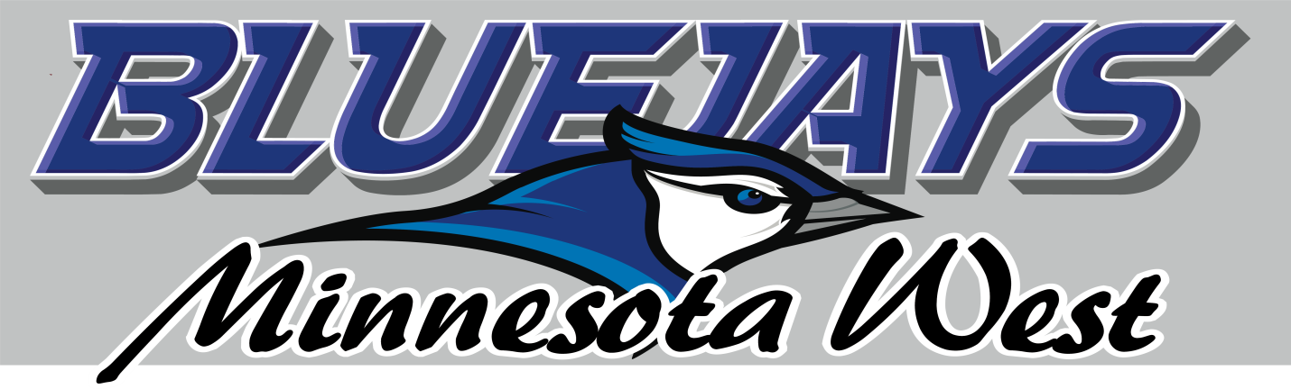
Waiver of Liability, Release, and Indemnification Agreement

I have voluntarily agreed to participate in __(INTRAMURAL SPORT)___ at Minnesota West Community and Technical College (Minnesota West).

I am aware of the dangers and risks to my person and property involved in participating in these activities. Risks associated with my participation in (INTRAMURAL SPORT) include, but are not limited to, loss of or damage to personal property, bodily injury, or even death. All such risks are known, understood, and assumed by me.

In consideration of the College’s agreement to permit me to participate in this activity, the receipt and sufficiency of which is hereby acknowledged, I agree as follows:

1) I agree to abide by the safety rules and regulations as set by Minnesota West. Failure to do so will disqualify me from participation.

2) I, individually, and on behalf of my heirs, successors, assigns and personal representatives, hereby release and forever discharge the College, the State of Minnesota, and its employees, agents, officers, trustees and representatives (in their official and individual capacities) (“Releasees”) from any and all liability whatsoever for any and all damages, losses or injuries (including death) I sustain to my person or property or both, including but not limited to any claims, demands, actions, causes of action, judgments, damages, expenses and costs, including attorney fees, which arise out of, result from, occur during, or are connected in any manner with my participation in Student Life trips whether caused by the negligence of the Releasees or otherwise; except that which is the result of gross negligence and/or wanton misconduct by the Releasees

3) I, individually, and on behalf of my heirs, successors, assigns and personal representatives, hereby agree to indemnify, defend and hold harmless the College, the State of Minnesota, and its employees, agents, officers, trustees and representatives (in their official and individual capacities) from any and all liability, loss, damage or expense, including attorney fees, that they or any of them incur or sustain as a result of any claims, demands, actions, causes of action, damages, judgments, costs or expenses, including attorney’s fees, which arise out of, occur during, or are in any way connected with my participation in Student Life sponsored activities.

4) I hereby consent to receive medical treatment that may be deemed advisable in the event of injury, accident or illness during this activity or event.

I agree that this Waiver, Release and Indemnification Agreement is to be construed under the laws of the State of Minnesota, U.S.A.; and that if any portion is held invalid, the balance shall, notwithstanding, continue in full legal force and effect. I agree that this Agreement is to be construed broadly to provide a release, indemnification and waiver to the maximum extent permissible under applicable law.

In signing this document, I hereby acknowledge that I have read this entire document, that I understand its terms, that I am at least eighteen (18) years of age, that by signing it I am giving up substantial legal rights I might otherwise have, and that I have signed it knowingly and voluntarily.

Name Student ID_______________

Signature Date

NOTICE: If participant is under the age of 18, his or her parent or legal guardian must sign:

I, (printed name) ________________________________________________, am the parent or legal guardian of the participant who has signed above. I have read and I understand the provisions of this document, I consent to the participant taking part in the activities described above, and I fully enter into and agree to the above Waiver of Liability, Release, and Indemnification Agreement.

Signature of Parent or Legal Guardian (Date)

