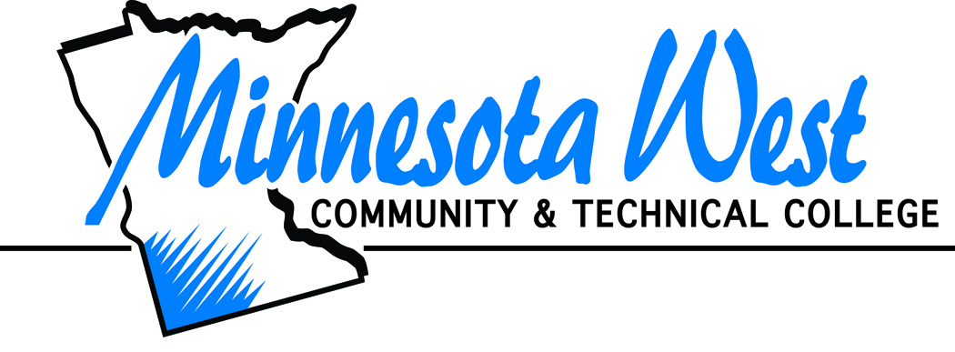

Emeritus Status Form

Nominee Information
Employee Name:
Phone:
Address:
Dates of Service:

Eligibility
- Must be a retired employee who was employed as a full-time faculty member at Minnesota West Community and Technical College for at least 10 academic years. Academic years can be consecutive or non-contiguous.
- Demonstrated excellence in the performance of a well-rounded set of professional responsibilities at the college. Those responsibilities may include: teaching, scholarship, student development, committee work, advising, co-curricular activities, and community involvement.

Nomination/Selection
Please explain why you think this individual should receive this outstanding recognition award:

Signature/Date:
Nominations for emeritus status can be made by any full-time Minnesota West employee who was employed by the college for the full academic year immediately prior to the nomination. Nominations must be submitted to the provost prior to the first day of the spring semester for consideration. A formal nomination form, along with nomination criteria, will be maintained on the college’s website. Applications for emeritus status will be discussed by the President’s Cabinet. The final decision will be made by the President during the spring semester of the academic year in which nominations are received. Policy 4.3 http://www.mnwest.edu/index.php/policies/48

